Local authority collaboration regarding planning and development
“Misr University for Science and Technology” activates a cooperation protocol with the Leaders Preparation Center for cultural and artistic activities, The Minister of Social Solidarity visits Misr University for Science and Technology and invites students to volunteer and participate in development programs, The Ministers of Investment and Finance inaugurate the First International Scientific Conference on Entrepreneurship and Women Empowerment at Misr University for Science and Technology. The Minister of Youth and Sports interviews the youth of Misr University for Science and Technology for the symposium “Egypt First… No to Intolerance”
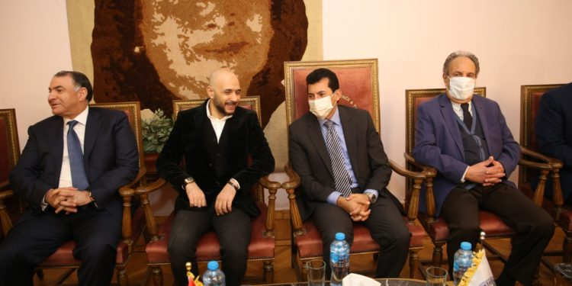

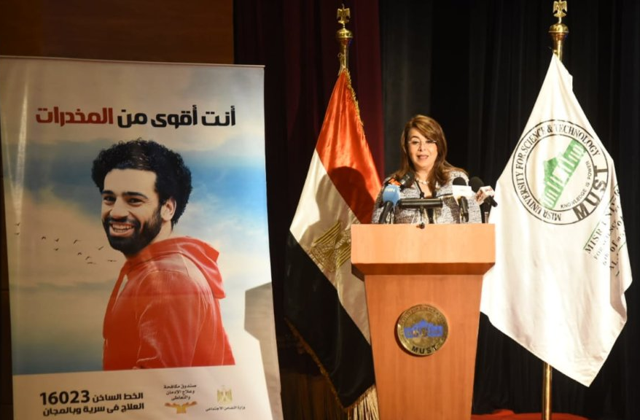

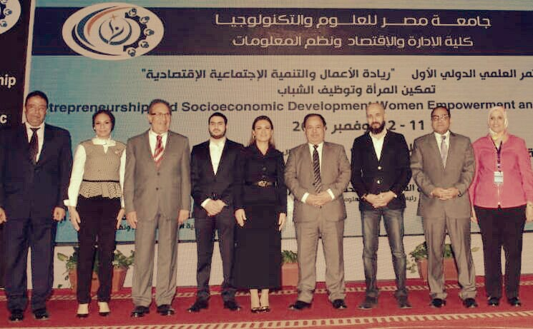

More Links:
https://www.wataninet.com/tag/%D8%AC%D8%A7%D9%85%D8%B9%D8%A9-%D9%85%D8%B5%D8%B1-%D9%84%D9%84%D8%B9%D9%84%D9%88%D9%85-%D9%88%D8%A7%D9%84%D8%AA%D9%83%D9%86%D9%88%D9%84%D9%88%D8%AC%D9%8A%D8%A7/

https://www.wataninet.com/2019/08/%d9%85%d8%b5%d8%b1-%d9%84%d9%84%d8%b9%d9%84%d9%88%d9%85-%d8%aa%d9%81%d8%b9%d9%84-%d8%a8%d8%b1%d9%88%d8%aa%d9%88%d9%83%d9%88%d9%84-%d8%a7%d9%84%d8%aa%d8%b9%d8%a7%d9%88%d9%86-%d9%85%d8%b9-%d9%85/

https://www.wataninet.com/2018/11/%d9%88%d8%a7%d9%84%d9%8a-%d8%aa%d8%b2%d9%88%d8%b1-%d8%ac%d8%a7%d9%85%d8%b9%d8%a9-%d9%85%d8%b5%d8%b1-%d9%84%d9%84%d8%b9%d9%84%d9%88%d9%85-%d9%88%d8%a7%d9%84%d8%aa%d9%83%d9%86%d9%88%d9%84%d9%88%d8%ac/
https://www.wataninet.com/2018/11/%d9%88%d8%b2%d9%8a%d8%b1%d8%a7-%d8%a7%d9%84%d8%a7%d8%b3%d8%aa%d8%ab%d9%85%d8%a7%d8%b1-%d9%88%d8%a7%d9%84%d9%85%d8%a7%d9%84%d9%8a%d8%a9-%d9%8a%d9%81%d8%aa%d8%aa%d8%ad%d8%a7%d9%86-%d8%a7%d9%84%d9%85/

