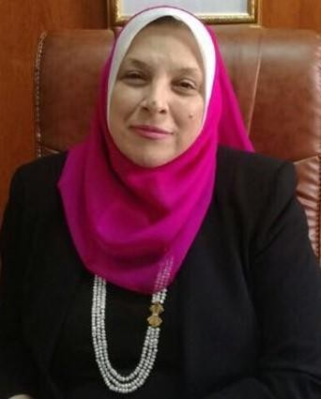
Title of presentation:
Sustainable Development in Pharmacy: Present & Future
Biography
Name : Salwa Elsayed Mohamed Elmeligie
Title : Professor of Organic Chemistry.

Academic & Professional Posts

- Quality Consultant for Higher Education since 2011 till now.

- Member of the Pharmaceutical Studies Sector Committee, Supreme Council of Universities, since November 2017 till 2021

- The Founder and the Former Dean of Faculty of Pharmacy, Sadat City University, since the preparation of the faculty 2014 till October 14, 2017.

- Ex-head of Pharmaceutical Organic Chemistry Department, Faculty of Pharmacy, Cairo University, since November 2011 to August 2016.

- Member of preparation NARS 2017 (CBE) by NAQAAE, April 2016.

- Author of “Green Pharmacy Education Book”, published by Lap Lambert Academic Publishing, Germany, April 2016

- Deputized at the National Authority of Quality Assurance and Accreditation of Education (NAQAAE), Egypt, from 2014 till 2016.

- Head of the team of reviewers conducted by the National Authority of Quality Assurance and Accreditation of Education (NAQAAE) for Accreditation Teams since 2011.

- Evaluation member conducted from the Permanent Pharmaceutical Studies Committee of Professors and Assistant Professors, promotion since 2009.

- The Founder and the Former Director of Career Center, Faculty of Pharmacy, Cairo University, from 2012 to September 2013.

