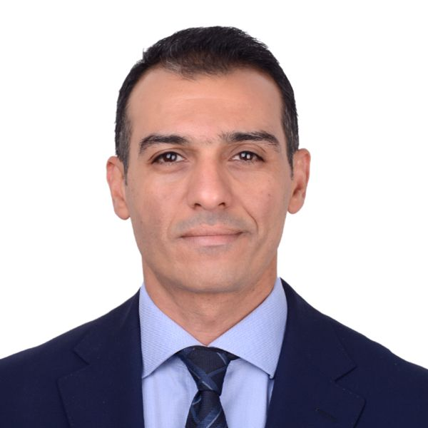

Dr Islam Anan
-Founder and CEO of Accsight L.L.C.
- Lecturer of Health Policy, Health Economics and Pharmacoepidemiology (Faculty of Pharmacy - Ain Shams University and MIU)
- Lecturer of Medical Journalism (The American University in Cairo)
- Health Policy and Health Economics Consultant to the presidential initiatives dept. at the Egyptian Ministry of Health and Population
- Health Policy and Health Economics Consultant - UNICEF

