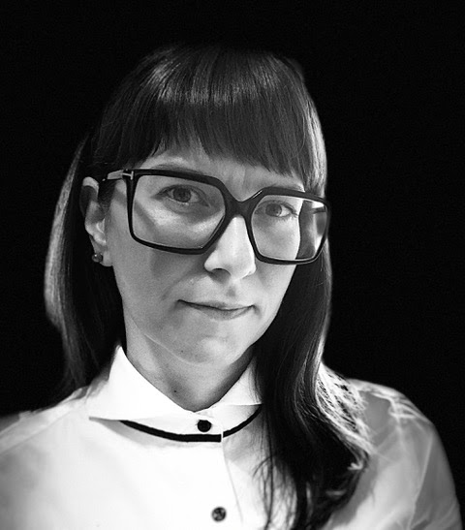
Dr. Theodora Katsila serves as a Research Assistant Professor - Head of the Biomarker Discovery & Translational Research laboratory at the Institute of Chemical Biology, National Hellenic Research Foundation, Greece. Her team applies a. mass spectrometry-based multi-omics and profiling of extracellular vesicles, b. 3D cell models and cheminformatics, c. ADME-Tox in 3D, and d. machine learning, deep learning and computational statistics to disrupt healthcare solutions and empower biomedical innovation.
Dr. Katsila is an expert in translational biomarkers upon the chemical biology prism, namely both molecular and digital biomarkers. She is actively involved in policy-making, standardization and open-science initiatives as a Global Genomic Medicine Initiative steering committee member and Family Health History flagship project co-chair, Human Proteome Organization committee member, Metabolomics Society member and Females in Mass Spectrometry mentor. She is a prolific author, editor, and speaker; a recipient of corporate, national and European grants; an award-winning scientist; and a co-inventor of a patent.

