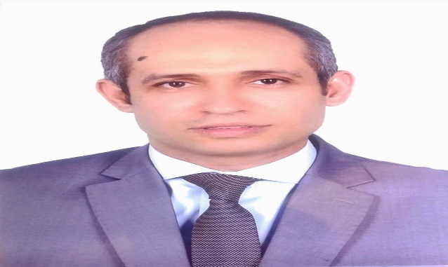

Islam Usama
Pharmacovigilance manager - MUP
Global Qualified person for Pharmacovigilance
(QPPV)

